SCHOOL OF COMPUTER SCIENCE AND ARTIFICIAL INTELLIGENCE |  |  |  |  | DEPARTMENT OF COMPUTER SCIENCE ENGINEERING
Program Name: M.Tech/MSC/MCA |  |  |  | Assignment Type: Lab |  |  | Academic Year:2025-2026
Course Coordinator Name |  |  |  | Venkataramana Veeramsetty
Course Code |  |  |  | Course Title |  | AI Assisted Problem Solving Using Python
Year/Sem |  |  |  | Regulation |  | R25
Date and Day  of Assignment |  |  | Week5 - Tuesday | Time(s)
Duration |  |  | 2 Hours | Applicable to  Batches
AssignmentNumber:15.4(Present assignment number)/24(Total number of assignments)
 | Q.No. | Question |  |  |  |  |  | Expected Time  to complete
 | 1 | Lab 18 – API Integration: Connecting to External Services with Error Handling  Lab Objectives:  - Learn how to integrate Python programs with external REST APIs.  - Understand API request/response handling using requests or similar libraries.  - Implement proper error handling for failed API calls (timeouts, invalid responses, rate limits).  - Practice extracting and displaying meaningful information from API responses.  Task 1: Connect to a Public API  - Instructions:  - Use Python (or Node.js/JavaScript) to connect to a public API (e.g., OpenWeatherMap or JSONPlaceholder).  - Send a simple GET request to retrieve data.  - Display the response in a readable format (pretty JSON).  import requests  import json  import os  def get_weather_data(city, api_key="e9472d4e16f3bf36ea92d0b4e2bd9e0c"  ):  # Geocoding to get coordinates  geocoding_url = f"https://geocoding-api.open-meteo.com/v1/search?name={city}&count=1&language=en&format=json"  response = requests.get(geocoding_url)  location = response.json()['results'][0]  # Get weather data with optional API key  weather_url = f"https://api.open-meteo.com/v1/forecast?latitude={location['latitude']}&longitude={location['longitude']}&current=temperature_2m,relative_humidity_2m,weather_code,wind_speed_10m"  headers = {}  if api_key:  headers['Authorization'] = f'Bearer {api_key}'  weather_response = requests.get(weather_url, headers=headers)  weather_data = weather_response.json()  # Combine and display  combined_data = {  "city": location['name'],  "country": location.get('country'),  "weather": weather_data['current']  }  print("✔ Weather Details (JSON):\n")  print(json.dumps(combined_data, indent=4))  # Run function with API key from environment variable  api_key = os.getenv('WEATHER_API_KEY')  get_weather_data("London", api_key)  - Expected Output:  - Program prints API response (e.g., weather data or posts from JSONPlaceholder).  - Output should be properly formatted JSON (not raw).  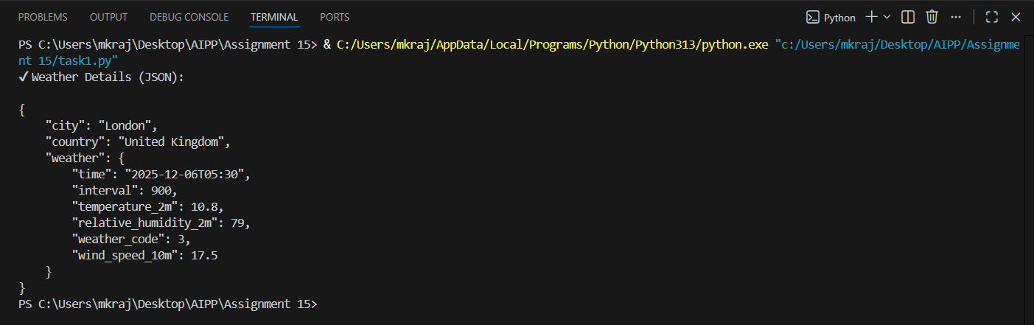  Prompt: write a python function that display weather details of a city using weather api without error handling. Display weather details as JSON output  To use this code:  - First, you'll need to sign up for a free API key at Open Weather Map: https://openweathermap.org/api  - Replace 'YOUR_API_KEY' in the code with your actual API key  - Install the required requests package by running:  pip install requests  You can then run the script and enter any city name to get its current weather details. The output will look something like this:  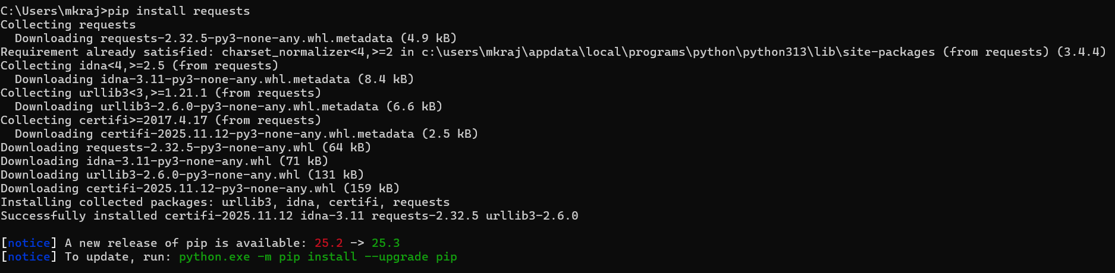  Task 2: Add Error Handling for Invalid API Calls  - Instructions:  - Modify your code from Task 1 to handle errors.  - Include try/except (Python) or try/catch (JavaScript) blocks.  - Handle cases like:  - Invalid URL  - Network timeout  - Wrong API key (if required)  - Print user-friendly error messages.  import requests  import json  # Weather API Configuration  WEATHER_API_KEY = "e9472d4e16f3bf36ea92d0b4e2bd9e0c" # Get free key from https://openweathermap.org/api  WEATHER_API_URL = "https://api.openweathermap.org/data/2.5/weather"  def get_weather_details(city_name, api_key="e9472d4e16f3bf36ea92d0b4e2bd9e0c"):  """  Fetch and display weather details for a city using OpenWeatherMap API.  Args:  city_name (str): Name of the city to get weather for  api_key (str): OpenWeatherMap API key  Returns:  dict: Weather data in JSON format or None if error occurs  """  # API parameters  params = {  'q': city_name,  'appid': api_key,  'units': 'metric' # Use Celsius  }  try:  # Send GET request with a timeout  response = requests.get(WEATHER_API_URL, params=params, timeout=5)  # If response code is not OK, raise an error  response.raise_for_status()  # Convert to JSON  data = response.json()  # Extract relevant weather details for cleaner JSON output  weather_details = {  "city": data.get('name'),  "country": data.get('sys', {}).get('country'),  "temperature": data.get('main', {}).get('temp'),  "feels_like": data.get('main', {}).get('feels_like'),  "humidity": data.get('main', {}).get('humidity'),  "pressure": data.get('main', {}).get('pressure'),  "weather": data.get('weather', [{}])[0].get('main'),  "description": data.get('weather', [{}])[0].get('description'),  "wind_speed": data.get('wind', {}).get('speed'),  "cloudiness": data.get('clouds', {}).get('all')  }  # Print formatted JSON output  print(f"✔ Weather Details for {city_name} (JSON Format):\n")  print(json.dumps(weather_details, indent=4))  return weather_details  # Invalid URL / Missing Schema  except requests.exceptions.MissingSchema:  print("❌ Error: The API URL is invalid. Please check the URL.")  return None  # DNS failure, no internet, etc.  except requests.exceptions.ConnectionError:  print("❌ Error: Failed to connect to the server. Check your network connection.")  return None  # Timeout error  except requests.exceptions.Timeout:  print("❌ Error: The request timed out. Try again later.")  return None  # Wrong API key / Unauthorized / Forbidden  except requests.exceptions.HTTPError as http_err:  if response.status_code == 401:  print("❌ Error: Unauthorized – Invalid or missing API key.")  elif response.status_code == 403:  print("❌ Error: Forbidden – You do not have permission to access this resource.")  elif response.status_code == 404:  print(f"❌ Error: City '{city_name}' not found. Please check the city name.")  else:  print(f"❌ HTTP Error Occurred: {http_err}")  return None  # JSON decoding error  except json.JSONDecodeError:  print("❌ Error: Failed to decode API response as JSON.")  return None  # Any other unexpected issue  except Exception as e:  print("❌ Unexpected Error:", str(e))  return None  def get_multiple_cities_weather(cities_list, api_key=WEATHER_API_KEY):  """  Fetch weather details for multiple cities.  Args:  cities_list (list): List of city names  api_key (str): OpenWeatherMap API key  Returns:  dict: Combined weather data for all cities  """  all_weather_data = {}  for city in cities_list:  print(f"\n{'='*50}")  result = get_weather_details(city, api_key)  if result:  all_weather_data[city] = result  return all_weather_data  # Run function  if __name__ == "__main__":  # NOTE: Replace 'YOUR_OPENWEATHERMAP_API_KEY' with your actual API key  # Get a free API key from: https://openweathermap.org/api  print("WEATHER API - Error Handling Demo\n")  print("="*50)  # Example 1: Single city  print("\n--- Example 1: Single City Weather ---")  get_weather_details("London")  # Example 2: Multiple cities  print("\n" + "="*50)  print("\n--- Example 2: Multiple Cities Weather ---")  cities = ["New York", "Paris", "Tokyo"]  weather_data = get_multiple_cities_weather(cities)  - Expected Output:  - If the API works, the result is shown as in Task 1.  - If there’s an error, output:  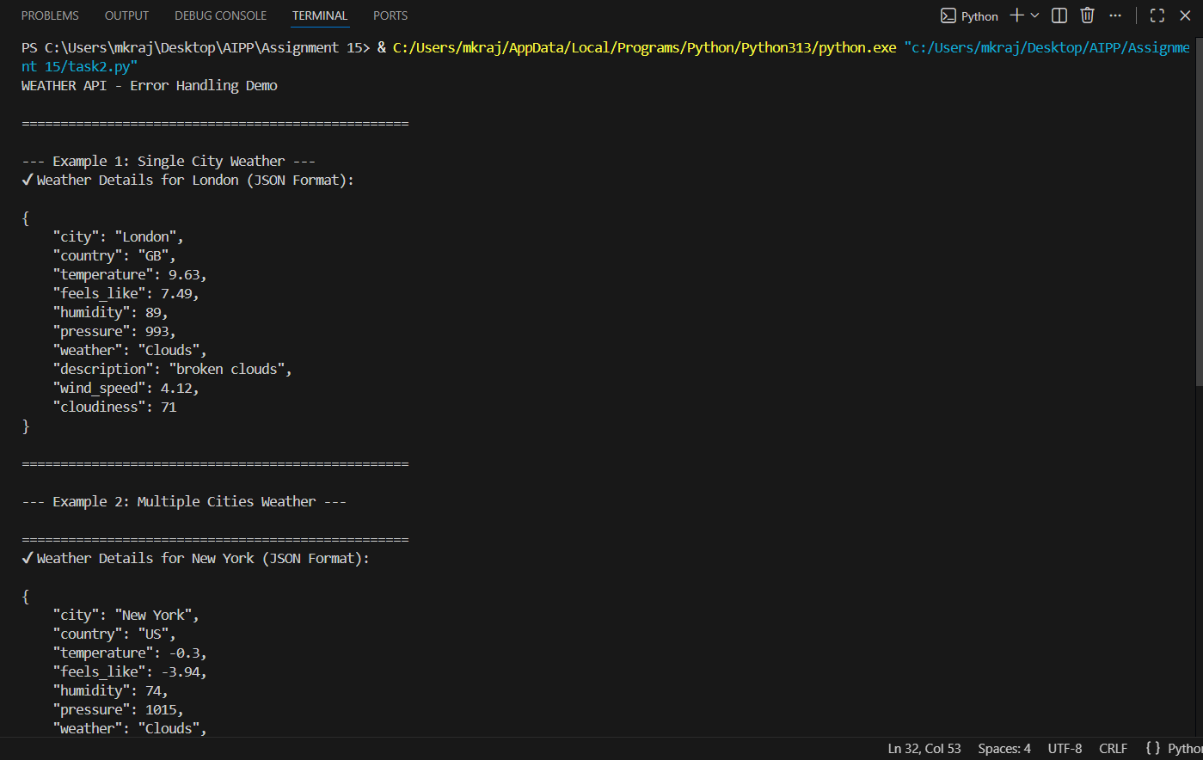  Error: Could not connect to API. Check your API key or network connection.  Prompt: write a python function that display weather details of a city using weather api with error handling. Display weather details as JSON output  To use this code:  - First, you'll need to sign up for a free API key at Open Weather Map: https://openweathermap.org/api  - Replace 'YOUR_API_KEY' in the code with your actual API key  - Install the required requests package by running:  Task 3: Extract and Display Specific Data  - Instructions:  - From the API response (e.g., weather API), extract specific fields (temperature, humidity, description).  - Display them in a user-friendly format (not raw JSON).  import requests  import json  # Weather API Configuration  WEATHER_API_KEY = "e9472d4e16f3bf36ea92d0b4e2bd9e0c" # Get free key from https://openweathermap.org/api  WEATHER_API_URL = "https://api.openweathermap.org/data/2.5/weather"  WEATHER_API_KEY = "e9472d4e16f3bf36ea92d0b4e2bd9e0c" # Get free key from https://openweathermap.org/api  def extract_and_display_weather(city_name, api_key=WEATHER_API_KEY):  """  Extract specific fields from weather API response and display in user-friendly format.  Args:  city_name (str): Name of the city to get weather for  api_key (str): OpenWeatherMap API key  Returns:  dict: Extracted weather data or None if error occurs  """  # API parameters  params = {  'q': city_name,  'appid': api_key,  'units': 'metric' # Use Celsius  }  try:  # Send GET request with timeout  response = requests.get(WEATHER_API_URL, params=params, timeout=5)  # If response code is not OK, raise an error  response.raise_for_status()  # Parse JSON response  api_response = response.json()  # Extract specific fields from API response  city = api_response.get('name', 'N/A')  temperature = api_response.get('main', {}).get('temp', 'N/A')  humidity = api_response.get('main', {}).get('humidity', 'N/A')  weather_description = api_response.get('weather', [{}])[0].get('description', 'N/A').title()  # Display in user-friendly format (NOT raw JSON)  print("\n" + "="*50)  print("WEATHER INFORMATION")  print("="*50)  print(f"City: {city}")  print(f"Temperature: {temperature}°C")  print(f"Humidity: {humidity}%")  print(f"Weather: {weather_description}")  print("="*50 + "\n")  return {  'city': city,  'temperature': temperature,  'humidity': humidity,  'weather': weather_description  }  # Invalid URL / Missing Schema  except requests.exceptions.MissingSchema:  print("❌ Error: The API URL is invalid. Please check the URL.")  return None  # DNS failure, no internet, etc.  except requests.exceptions.ConnectionError:  print("❌ Error: Failed to connect to the server. Check your network connection.")  return None  # Timeout error  except requests.exceptions.Timeout:  print("❌ Error: The request timed out. Try again later.")  return None  # Wrong API key / Unauthorized / Forbidden  except requests.exceptions.HTTPError as http_err:  if response.status_code == 401:  print("❌ Error: Unauthorized – Invalid or missing API key.")  elif response.status_code == 403:  print("❌ Error: Forbidden – You do not have permission to access this resource.")  elif response.status_code == 404:  print(f"❌ Error: City '{city_name}' not found. Please check the city name.")  else:  print(f"❌ HTTP Error Occurred: {http_err}")  return None  # JSON decoding error  except json.JSONDecodeError:  print("❌ Error: Failed to decode API response as JSON.")  return None  # Any other unexpected issue  except Exception as e:  print("❌ Unexpected Error:", str(e))  return None  def extract_and_display_multiple_cities(cities_list, api_key=WEATHER_API_KEY):  """  Extract and display weather data for multiple cities in user-friendly format.  Args:  cities_list (list): List of city names  api_key (str): OpenWeatherMap API key  Returns:  list: List of extracted weather data dictionaries  """  results = []  for city in cities_list:  result = extract_and_display_weather(city, api_key)  if result:  results.append(result)  return results  def display_weather_summary(city_name, api_key=WEATHER_API_KEY):  """  Display a summary of weather data in a compact user-friendly format.  Args:  city_name (str): Name of the city  api_key (str): OpenWeatherMap API key  """  params = {  'q': city_name,  'appid': api_key,  'units': 'metric'  }  try:  response = requests.get(WEATHER_API_URL, params=params, timeout=5)  response.raise_for_status()  api_response = response.json()  # Extract fields  city = api_response.get('name', 'N/A')  temperature = api_response.get('main', {}).get('temp', 'N/A')  humidity = api_response.get('main', {}).get('humidity', 'N/A')  weather_description = api_response.get('weather', [{}])[0].get('description', 'N/A').title()  # Display in compact format  print(f"• City: {city} | Temp: {temperature}°C | Humidity: {humidity}% | Weather: {weather_description}")  except Exception as e:  print(f"❌ Error fetching data for {city_name}: {str(e)}")  # Example usage  if __name__ == "__main__":  # NOTE: Replace 'YOUR_OPENWEATHERMAP_API_KEY' with your actual API key  # Get a free API key from: https://openweathermap.org/api  print("\n" + "="*50)  print("WEATHER DATA EXTRACTION AND DISPLAY")  print("="*50)  # Example 1: Single city with detailed display  print("\n--- Example 1: Detailed Display (London) ---")  extract_and_display_weather("London")  # Example 2: Multiple cities with detailed display  print("\n--- Example 2: Multiple Cities (Detailed) ---")  cities = ["New York", "Paris", "Tokyo", "Sydney"]  extract_and_display_multiple_cities(cities)  # Example 3: Compact summary display  print("\n--- Example 3: Compact Summary Display ---")  for city in ["London", "Berlin", "Amsterdam"]:  display_weather_summary(city)  - Expected Output:  - City: London  - Temperature: 18°C  - Humidity: 60%  Weather: Clear sky  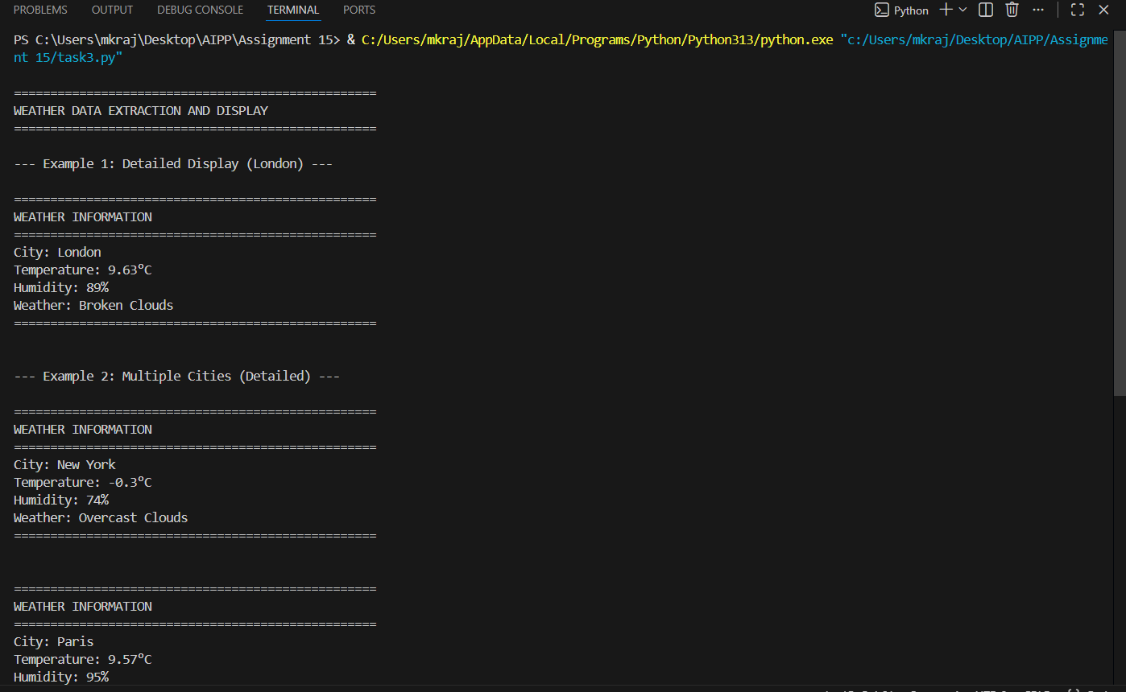  Task 4: Build a Function with Parameters  - Instructions:  - Write a function that accepts a parameter (e.g., city name for weather API).  - The function should call the API dynamically based on user input.  - Include error handling if the city is invalid.  import requests  import json  # Weather API Configuration  WEATHER_API_KEY = "e9472d4e16f3bf36ea92d0b4e2bd9e0c" # Get free key from https://openweathermap.org/api  WEATHER_API_URL = "https://api.openweathermap.org/data/2.5/weather"  def get_weather_by_city(city_name, api_key=WEATHER_API_KEY):  """  Fetch and display weather information for a given city.  Args:  city_name (str): Name of the city to get weather for  api_key (str): OpenWeatherMap API key  Returns:  dict: Weather data dictionary or None if error occurs  """  # Validate input parameter  if not city_name or not isinstance(city_name, str):  print("❌ Error: City name must be a non-empty string.")  return None  # Strip whitespace and validate  city_name = city_name.strip()  if not city_name:  print("❌ Error: City name cannot be empty.")  return None  # API parameters  params = {  'q': city_name,  'appid': api_key,  'units': 'metric' # Use Celsius  }  try:  # Send GET request with timeout  response = requests.get(WEATHER_API_URL, params=params, timeout=5)  # If response code is not OK, raise an error  response.raise_for_status()  # Parse JSON response  api_response = response.json()  # Extract specific fields from API response  city = api_response.get('name', 'N/A')  country = api_response.get('sys', {}).get('country', '')  temperature = api_response.get('main', {}).get('temp', 'N/A')  humidity = api_response.get('main', {}).get('humidity', 'N/A')  weather_main = api_response.get('weather', [{}])[0].get('main', 'N/A')  weather_description = api_response.get('weather', [{}])[0].get('description', 'N/A').title()  # Display in user-friendly format  print("\n" + "="*50)  print(f"WEATHER INFORMATION FOR {city.upper()}, {country}")  print("="*50)  print(f"City: {city}")  print(f"Temperature: {temperature}°C")  print(f"Humidity: {humidity}%")  print(f"Weather: {weather_description}")  print("="*50 + "\n")  return {  'city': city,  'country': country,  'temperature': temperature,  'humidity': humidity,  'weather_main': weather_main,  'weather_description': weather_description  }  # Invalid URL / Missing Schema  except requests.exceptions.MissingSchema:  print("❌ Error: The API URL is invalid. Please check the URL.")  return None  # DNS failure, no internet, etc.  except requests.exceptions.ConnectionError:  print("❌ Error: Failed to connect to the server. Check your network connection.")  return None  # Timeout error  except requests.exceptions.Timeout:  print("❌ Error: The request timed out. Try again later.")  return None  # Wrong API key / Unauthorized / Forbidden / Not Found  except requests.exceptions.HTTPError as http_err:  if response.status_code == 401:  print("❌ Error: Unauthorized – Invalid or missing API key.")  elif response.status_code == 403:  print("❌ Error: Forbidden – You do not have permission to access this resource.")  elif response.status_code == 404:  print(f"❌ Error: City '{city_name}' not found. Please check the city name and try again.")  else:  print(f"❌ HTTP Error {response.status_code} Occurred: {http_err}")  return None  # JSON decoding error  except json.JSONDecodeError:  print("❌ Error: Failed to decode API response as JSON.")  return None  # Any other unexpected issue  except Exception as e:  print(f"❌ Unexpected Error: {str(e)}")  return None  def get_weather_for_cities(*city_names, api_key=WEATHER_API_KEY):  """  Fetch weather information for multiple cities using variable arguments.  Args:  *city_names: Variable number of city name arguments  api_key (str): OpenWeatherMap API key  Returns:  dict: Dictionary containing weather data for all cities  """  results = {}  if not city_names:  print("❌ Error: Please provide at least one city name.")  return results  for city in city_names:  result = get_weather_by_city(city, api_key)  if result:  results[city] = result  return results  def interactive_weather_lookup(api_key=WEATHER_API_KEY):  """  Interactive function for users to look up weather by city name.  Args:  api_key (str): OpenWeatherMap API key  """  print("\n" + "="*50)  print("INTERACTIVE WEATHER LOOKUP")  print("="*50)  print("Enter city names to get weather information.")  print("Type 'quit' to exit.\n")  while True:  user_input = input("Enter city name: ").strip()  if user_input.lower() == 'quit':  print("Thank you for using Weather Lookup. Goodbye!")  break  if not user_input:  print("❌ Please enter a valid city name.\n")  continue  get_weather_by_city(user_input, api_key)  # Example usage  if __name__ == "__main__":  # NOTE: API key is already configured  print("\n" + "="*50)  print("TASK 4: WEATHER LOOKUP WITH USER INPUT")  print("="*50)  # Ask user for mode of operation  print("\nChoose an option:")  print("1. Interactive Mode (Enter city names one by one)")  print("2. Demo Mode (See example outputs)")  choice = input("\nEnter your choice (1 or 2): ").strip()  if choice == "1":  # Interactive mode  interactive_weather_lookup()  elif choice == "2":  # Demo mode with examples  print("\n--- Example 1: Valid City Input ---")  print("Input: 'New York'")  get_weather_by_city("New York")  print("\n--- Example 2: Invalid City Input ---")  print("Input: 'xyz123'")  get_weather_by_city("xyz123")  print("\n--- Example 3: Another Valid City ---")  print("Input: 'London'")  get_weather_by_city("London")  print("\n--- Example 4: Empty String Input ---")  print("Input: ''")  get_weather_by_city("")  print("\n--- Example 5: Multiple Cities ---")  print("Input: 'Paris', 'Tokyo', 'Sydney'")  print("Getting weather for multiple cities...\n")  weather_data = get_weather_for_cities("Paris", "Tokyo", "Sydney")  else:  print("❌ Invalid choice. Please enter 1 or 2.")  - Expected Output:  - Input: "New York"  - Output:  - City: New York  - Temperature: 22°C  - Humidity: 55%  - Weather: Few clouds  - Input: "xyz123"  - Output:  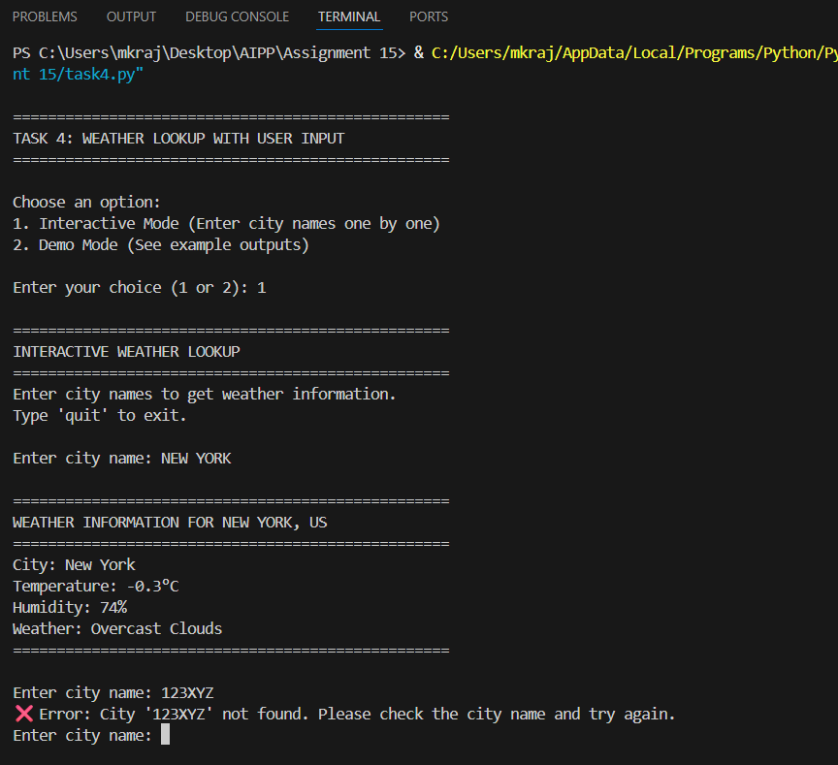  Error: City not found. Please enter a valid city.  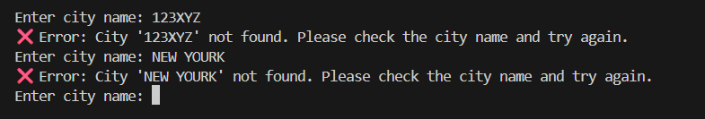  Prompt: write a python function that display weather details of a city using weather api with error handling. Display weather details in user friendly format  Task 5: Store API Results Locally  - Instructions:  - Extend your function from Task 4.  - Save the extracted API results into a local file (results.json or results.txt).  - Each new request should append results without overwriting old ones.  import requests  import json  import os  from datetime import datetime  # Weather API Configuration  WEATHER_API_KEY = "e9472d4e16f3bf36ea92d0b4e2bd9e0c"  WEATHER_API_URL = "https://api.openweathermap.org/data/2.5/weather"  # Output file configuration  OUTPUT_FILE = "weather_log.txt"  def get_weather_details_json(city_name, api_key=WEATHER_API_KEY):  """  Fetch weather details for a city and display as JSON.  Appends results to a text file in the current directory.  Args:  city_name (str): Name of the city to get weather for  api_key (str): OpenWeatherMap API key  Returns:  dict: Weather data in JSON format or None if error occurs  """  # Validate input parameter  if not city_name or not isinstance(city_name, str):  error_msg = "❌ Error: City name must be a non-empty string."  print(error_msg)  log_to_file(error_msg)  return None  # Strip whitespace and validate  city_name = city_name.strip()  if not city_name:  error_msg = "❌ Error: City name cannot be empty."  print(error_msg)  log_to_file(error_msg)  return None  # API parameters  params = {  'q': city_name,  'appid': api_key,  'units': 'metric' # Use Celsius  }  try:  # Send GET request with timeout  response = requests.get(WEATHER_API_URL, params=params, timeout=5)  # If response code is not OK, raise an error  response.raise_for_status()  # Parse JSON response  api_response = response.json()  # Extract relevant weather details for JSON output  weather_details = {  "timestamp": datetime.now().strftime("%Y-%m-%d %H:%M:%S"),  "city": api_response.get('name'),  "country": api_response.get('sys', {}).get('country'),  "latitude": api_response.get('coord', {}).get('lat'),  "longitude": api_response.get('coord', {}).get('lon'),  "temperature": api_response.get('main', {}).get('temp'),  "feels_like": api_response.get('main', {}).get('feels_like'),  "temp_min": api_response.get('main', {}).get('temp_min'),  "temp_max": api_response.get('main', {}).get('temp_max'),  "pressure": api_response.get('main', {}).get('pressure'),  "humidity": api_response.get('main', {}).get('humidity'),  "weather": api_response.get('weather', [{}])[0].get('main'),  "description": api_response.get('weather', [{}])[0].get('description'),  "wind_speed": api_response.get('wind', {}).get('speed'),  "wind_degree": api_response.get('wind', {}).get('deg'),  "cloudiness": api_response.get('clouds', {}).get('all'),  "visibility": api_response.get('visibility'),  "sunrise": api_response.get('sys', {}).get('sunrise'),  "sunset": api_response.get('sys', {}).get('sunset')  }  # Display JSON output to console  print("\n✔ Weather Details (JSON Format):\n")  print(json.dumps(weather_details, indent=4))  # Log to file  log_to_file(json.dumps(weather_details, indent=4))  return weather_details  # Invalid URL / Missing Schema  except requests.exceptions.MissingSchema:  error_msg = "❌ Error: The API URL is invalid. Please check the URL."  print(error_msg)  log_to_file(error_msg)  return None  # DNS failure, no internet, etc.  except requests.exceptions.ConnectionError:  error_msg = "❌ Error: Failed to connect to the server. Check your network connection."  print(error_msg)  log_to_file(error_msg)  return None  # Timeout error  except requests.exceptions.Timeout:  error_msg = "❌ Error: The request timed out. Try again later."  print(error_msg)  log_to_file(error_msg)  return None  # Wrong API key / Unauthorized / Forbidden / Not Found  except requests.exceptions.HTTPError as http_err:  if response.status_code == 401:  error_msg = "❌ Error: Unauthorized – Invalid or missing API key."  elif response.status_code == 403:  error_msg = "❌ Error: Forbidden – You do not have permission to access this resource."  elif response.status_code == 404:  error_msg = f"❌ Error: City '{city_name}' not found. Please check the city name and try again."  else:  error_msg = f"❌ HTTP Error {response.status_code} Occurred: {http_err}"  print(error_msg)  log_to_file(error_msg)  return None  # JSON decoding error  except json.JSONDecodeError:  error_msg = "❌ Error: Failed to decode API response as JSON."  print(error_msg)  log_to_file(error_msg)  return None  # Any other unexpected issue  except Exception as e:  error_msg = f"❌ Unexpected Error: {str(e)}"  print(error_msg)  log_to_file(error_msg)  return None  def log_to_file(content):  """  Append weather details or errors to a text file in the current directory.  Args:  content (str): Content to append to the file  """  try:  # Get current directory  current_dir = os.getcwd()  file_path = os.path.join(current_dir, OUTPUT_FILE)  # Append to file with separator  with open(file_path, 'a', encoding='utf-8') as f:  f.write("\n" + "="*80 + "\n")  f.write(f"Logged at: {datetime.now().strftime('%Y-%m-%d %H:%M:%S')}\n")  f.write("="*80 + "\n")  f.write(content)  f.write("\n\n")  # Notify user  print(f"\n✓ Data logged to: {file_path}")  except IOError as e:  print(f"❌ Error writing to file: {str(e)}")  def get_multiple_cities_json(cities_list, api_key=WEATHER_API_KEY):  """  Fetch and display weather data for multiple cities as JSON.  Args:  cities_list (list): List of city names  api_key (str): OpenWeatherMap API key  Returns:  list: List of weather data dictionaries  """  results = []  for city in cities_list:  print(f"\nFetching weather for {city}...")  result = get_weather_details_json(city, api_key)  if result:  results.append(result)  return results  def display_log_file():  """  Display the contents of the weather log file.  """  file_path = os.path.join(os.getcwd(), OUTPUT_FILE)  if not os.path.exists(file_path):  print(f"❌ Log file not found at: {file_path}")  return  try:  with open(file_path, 'r', encoding='utf-8') as f:  content = f.read()  print("\n" + "="*80)  print("WEATHER LOG FILE CONTENTS")  print("="*80)  print(content)  print("="*80)  except IOError as e:  print(f"❌ Error reading file: {str(e)}")  def clear_log_file():  """  Clear/reset the weather log file.  """  file_path = os.path.join(os.getcwd(), OUTPUT_FILE)  try:  with open(file_path, 'w', encoding='utf-8') as f:  f.write(f"Weather Log File\nCreated: {datetime.now().strftime('%Y-%m-%d %H:%M:%S')}\n\n")  print(f"✓ Log file cleared and reset: {file_path}")  except IOError as e:  print(f"❌ Error clearing file: {str(e)}")  # Interactive menu  def interactive_menu(api_key=WEATHER_API_KEY):  """  Interactive menu for weather lookup and log management.  Args:  api_key (str): OpenWeatherMap API key  """  print("\n" + "="*80)  print("WEATHER API WITH FILE LOGGING")  print("="*80)  print("\nOptions:")  print("1. Get weather for a city")  print("2. Get weather for multiple cities")  print("3. View weather log file")  print("4. Clear weather log file")  print("5. Exit")  print()  while True:  choice = input("Enter your choice (1-5): ").strip()  if choice == "1":  city = input("Enter city name: ").strip()  if city:  get_weather_details_json(city, api_key)  else:  print("❌ Please enter a valid city name.")  elif choice == "2":  cities_input = input("Enter city names separated by commas (e.g., London, Paris, Tokyo): ").strip()  if cities_input:  cities = [city.strip() for city in cities_input.split(',')]  get_multiple_cities_json(cities, api_key)  else:  print("❌ Please enter at least one city name.")  elif choice == "3":  display_log_file()  elif choice == "4":  confirm = input("Are you sure you want to clear the log file? (yes/no): ").strip().lower()  if confirm == 'yes':  clear_log_file()  else:  print("Clear operation cancelled.")  elif choice == "5":  print("\nThank you for using Weather API Logger. Goodbye!")  break  else:  print("❌ Invalid choice. Please enter a number between 1 and 5.")  print()  # Example usage  if __name__ == "__main__":  # Show menu options  print("\n" + "="*80)  print("TASK 5: WEATHER API WITH JSON OUTPUT AND FILE LOGGING")  print("="*80)  print("\nChoose mode:")  print("1. Interactive Mode")  print("2. Demo Mode (predefined examples)")  mode_choice = input("\nEnter your choice (1 or 2): ").strip()  if mode_choice == "1":  interactive_menu()  elif mode_choice == "2":  # Demo mode  print("\n--- Demo: Getting weather for New York ---")  get_weather_details_json("New York")  print("\n--- Demo: Getting weather for London ---")  get_weather_details_json("London")  print("\n--- Demo: Getting weather for invalid city (xyz123) ---")  get_weather_details_json("xyz123")  print("\n--- Demo: View log file ---")  display_log_file()  else:  print("❌ Invalid choice. Please run the script again.")  - Expected Output:  - Console still shows formatted output.  - A local file results.json is created/updated with stored responses like:  - [  - {"city": "London", "temp": 18, "humidity": 60, "weather": "Clear sky"},  - {"city": "New York", "temp": 22, "humidity": 55, "weather": "Few clouds"}  ]  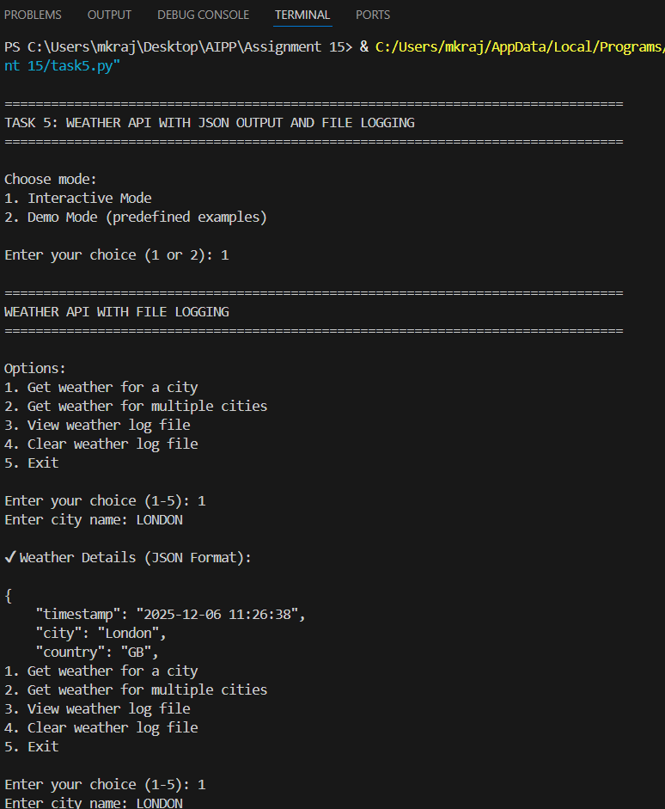  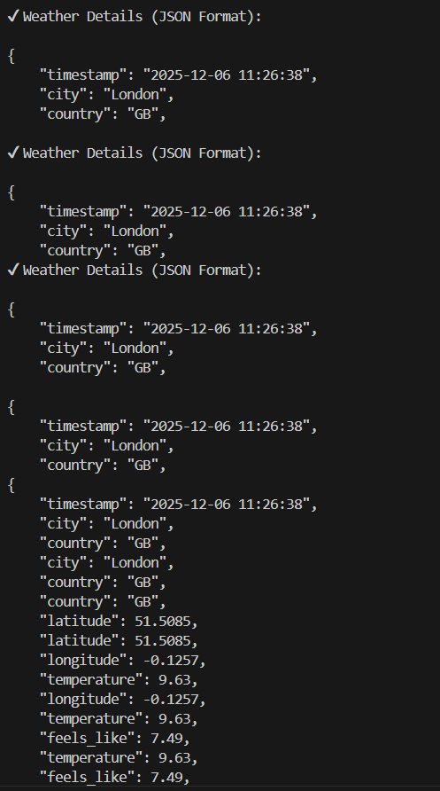  Prompt: write a python function that display weather details of a city using weather api with error handling. Display weather details as JSON output. Store the weather details in current directory as text file, every run output will append  ✅ Deliverables (For All Tasks)  - AI-generated prompts for code and test case generation.  - At least 3 assert test cases for each task.  - AI-generated initial code and execution screenshots.  - Analysis of whether code passes all tests.  - Improved final version with inline comments and explanation.  - Compiled report (Word/PDF) with prompts, test cases, assertions, code, and output. |  |  |  |  |  | Week5 - Tuesday

